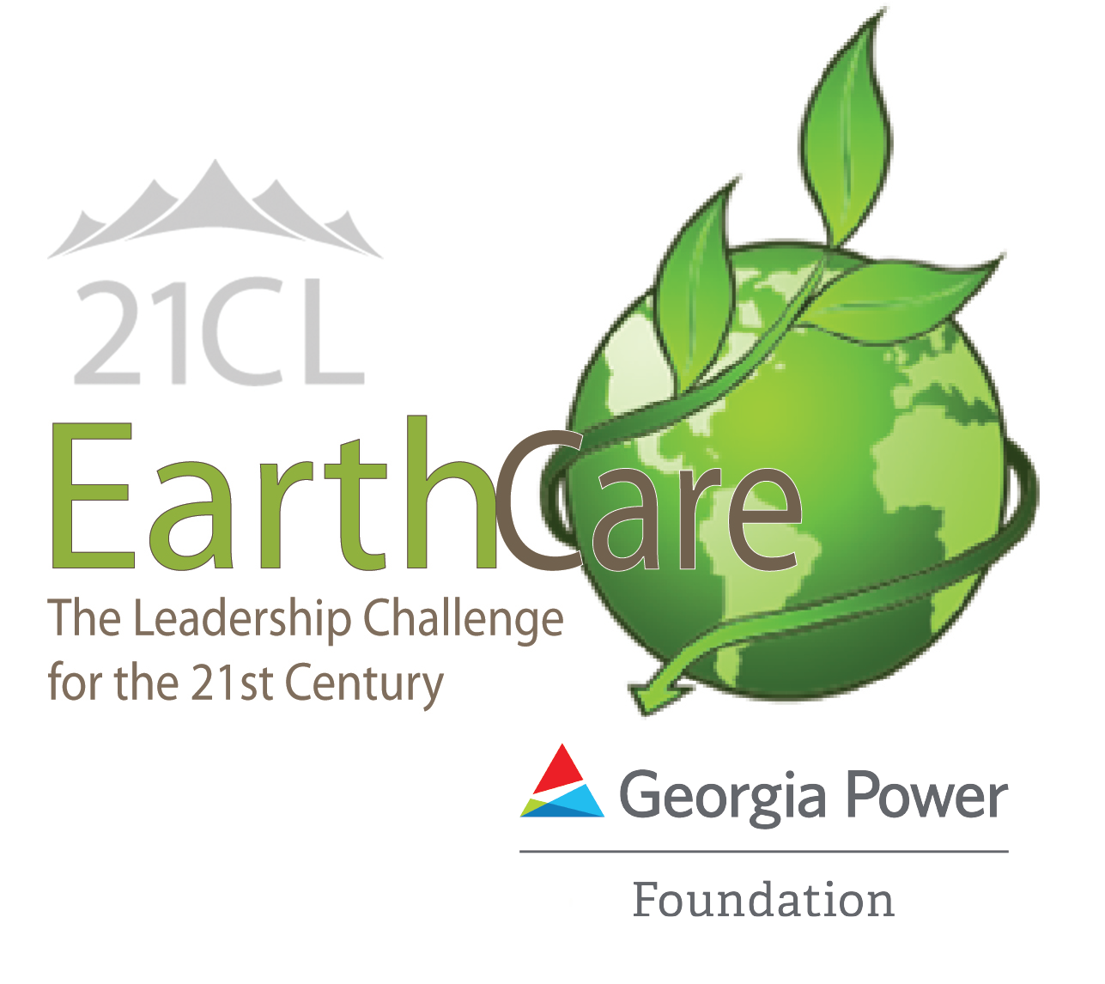
21st Century Leaders (21CL) is accepting applications for high school students in Georgia to attend one of our 2023 summer leadership institutes and to become a member of the state-wide youth leadership organization. If accepted, students will not only attend an experiential week on a college campus with diverse peers, they’ll also have access to our other programs offered throughout the year - fall and winter summits, online learning platform, special opportunities and more - for the rest of high school!

EarthCare is our STEM-focused institute supported by the Georgia Power Foundation; our other institutes include the business-focused SYLI@Goizueta and the healthcare-focused Healthcare & IT Institute.

TO APPLY
- Students must submit an online application to their preferred institute and then get a teacher, counselor, or youth leader to submit a separate recommendation form online.
  - Student Application: https://www.21stcenturyleaders.org/student-programs/summer/
  - Recommendation Form: https://www.21stcenturyleaders.org/student- programs/recommendation-form

- Current high school freshmen, sophomores and juniors (public, private or homeschool) in the state of Georgia may apply. No prior leadership experience is required, just an interest in developing as a leader!

- The deadline for applications is March 1st for SYLI or HII and March 15, 2023 for EarthCare. Applicants will be notified of their application results by email in early April.

- Final selections are the responsibility of 21st Century Leaders. Applications and recommendations are reviewed and rated by trained 21st Century Leaders volunteers and corporate professionals.

- 21CL will select 100 diverse students for the 2023 summer institute and make every effort to include students from all areas of Georgia.

- There is NO cost for students to attend EarthCare; financial coverage is available for the other institutes so finances should be of no concern to students who are accepted to attend.

- EarthCare 2023 will take place as a residential program on the campus of Georgia College & State University in Milledgeville, GA. Accepted students will need to be dropped off on Sunday, June 11 and picked up on Friday, June 16.

- Information and requests for assistance, contact Director of Programs and Operations, Tim Parham at 404-373-7441; tim@21stcenturyleaders.org

P.O. Box 1125 , Decatur, GA 30031 | tel 404.373.7441 fax 404.373.7442
www.21stcenturyleaders.org

